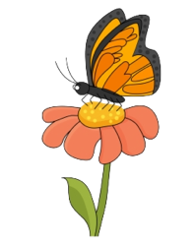
MAY 2023
Mrs. Roan & Miss Kelli Cardinals Class I/I+
Sun | Mon | Tue | Wed | Thu | Fri | Sat
 | 1 | 2 | 3 | 4 | 5 | 6
shapes of the Month  pentagon  Color white | Letter  Tt  Big Word  Tranquil | Number  25 | Steam  Planting Beans | Positive Images Graduation Pictures | Journal Page  Pictionary  Show and Tell
7 | 8 | 9 | 10 | 11 | 12 | 13
Artist of the Month  Mary Cassatt |  |  | Science | Cardinal Café  Fellowship Hall @11:00am
14 | 15 | 16 | 17 | 18 | 19 | 20
Happy Mother’s Day! | Letter  Jj  Big Word  Jubilant | Number  26 | Science | Pictionary  Show and Tell
21 | 22 | 23 | 24 | 25 | 26 | 27
Spring Progress Reports go home this week. |  | Number  27 | Happy Birthday  Tanner!  Journy Around the World  in Sing! |  | journal page
28 | 29 | 30 | 31
 | Memorial Day  No School | No School
 |  |  | Spring conference available upon request.

Sight Words: be, this, from, I, have

